Packet Tracer - Troubleshoot Inter-VLAN Routing – Physical Mode

# Topology

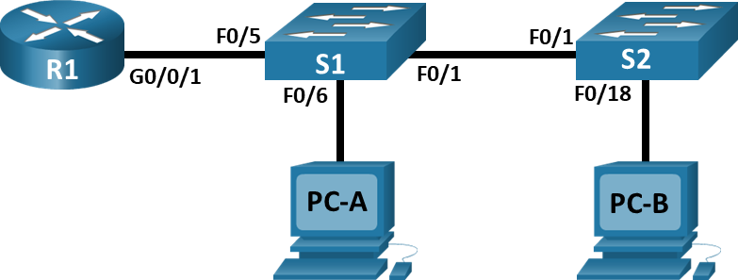

# Addressing Table

| Device | Interface | IP Address | Subnet Mask | Default Gateway |
| --- | --- | --- | --- | --- |
| R1 | G0/0/1.3 | 10.3.0.1 | 255.255.255.0 | N/A |
| R1 | G0/0/1.4 | 10.4.0.1 | 255.255.255.0 | N/A |
| R1 | G0/0/1.13 | 10.13.0.1 | 255.255.255.0 | N/A |
| S1 | VLAN 3 | 10.3.0.11 | 255.255.255.0 | 10.3.0.1 |
| S2 | VLAN 3 | 10.3.0.12 | 255.255.255.0 | 10.3.0.1 |
| PC-A | NIC | 10.4.0.50 | 255.255.255.0 | 10.4.0.1 |
| PC-B | NIC | 10.13.0.50 | 255.255.255.0 | 10.13.0.1 |

Blank Line - no additional information

# VLAN Table

|  |  |  |
| --- | --- | --- |
| VLAN | Name | Interface Assigned |
| 3 | Management | S1: VLAN 3  S2: VLAN 3 |
| 4 | Operations | S1: F0/6 |
| 7 | ParkingLot | S1: F0/2-4, F0/7-24, G0/1-2  S2: F0/2-17, F0/19-24, G0/1-2 |
| 8 | Native | N/A |
| 13 | Maintenance | S2: F0/18 |

Blank Line - no additional information

# Objectives

Part 1: Evaluate Network Operation

Part 2: Gather Information, Create an Action Plan, and Implement Corrections

# Background / Scenario

All the network devices in this Packet Tracer Physical Mode (PTPM) activity have been preconfigured to include intentional errors that are keeping the inter-VLAN routing from working. Your task is to evaluate the network, identify, and correct the configuration errors to restore full inter-VLAN connectivity. You may find errors with the configurations which are not directly related to inter-VLAN routing. These errors impact the ability of the network devices to perform this function.

**Note:** The design approach used in this activity is to assess your ability to configure and troubleshoot inter-VLAN routing only. This design may not reflect networking best practices.

# Instructions

## Evaluate Network Operation

**Requirements**:

* No VLAN 7 traffic is allowed on the trunks because there are no devices in VLAN 7.
* VLAN 8 is the native VLAN.
* All trunks are static.
* End to end connectivity.
  + - 1. Use the laptop computer and appropriate cable to console into the network devices for testing and configuration purposes. The login password on all network devices is **“cisco”** and the enable password is **“class”.** You can click and drag the console connection from the console port of one device to another, but you will have to start a new terminal session.
      2. Use the **ping** command to test the following criteria and record the results in the table below.

| From | To | Ping Results |
| --- | --- | --- |
| R1 | S1 VLAN 3 (10.3.0.11) | Success rate is 0 percent (0/5) |
| R1 | S2 VLAN 3 (10.3.0.12) | Success rate is 0 percent (0/5) |
| R1 | PC-A (10.4.0.50) | Success rate is 0 percent (0/5) |
| R1 | PC-B (10.13.0.50) | Success rate is 0 percent (0/5) |
| S1 | S2 VLAN 3 (10.3.0.12) | Success rate is 0 percent (0/5) |
| S1 | PC-A (10.4.0.50) | Success rate is 0 percent (0/5) |
| S1 | PC-B (10.13.0.50) | Success rate is 0 percent (0/5) |
| S2 | PC-A (10.4.0.50) | Success rate is 0 percent (0/5) |
| S2 | PC-B (10.13.0.50) | Success rate is 0 percent (0/5) |

Blank Line - no additional information

## Gather Information, Create an Action Plan, and Implement Corrections

* + - 1. For each requirement that is not met, gather information by examining the running configuration and the routing tables to develop a hypothesis for what is causing the malfunction.
      2. Create an action plan that you think will fix the issue. Develop a list of all the commands you intend to issue to fix the issue, and a list of all the commands you need to revert the configuration, should your action plan fail to correct the issue.

**Hint**: If you need to reset a switchport to default configuration, use the **default interface** *interface name* command.

As an example for F0/10:

S1(config)# **default interface f0/10**

* + - 1. Execute your action plans one at a time for each criterion that fails and record the fix actions.

Type your answers here.

end of document